**Accessing the Remote Desktop in Windows 10**

**Step 1: Enable Remote Desktop**

The remote desktop feature is disabled by default in Windows 10. To enable this feature on Thing2’s device:

1. Type “this pc” into the Windows search bar. Click on **properties** in the right-hand column:

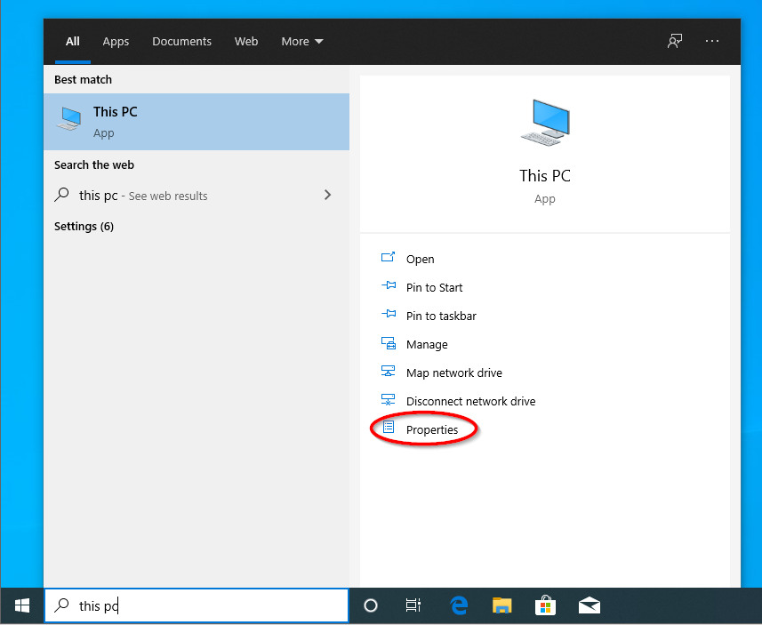

1. In the new window that opens, click **Remote Settings** in the left-hand column:

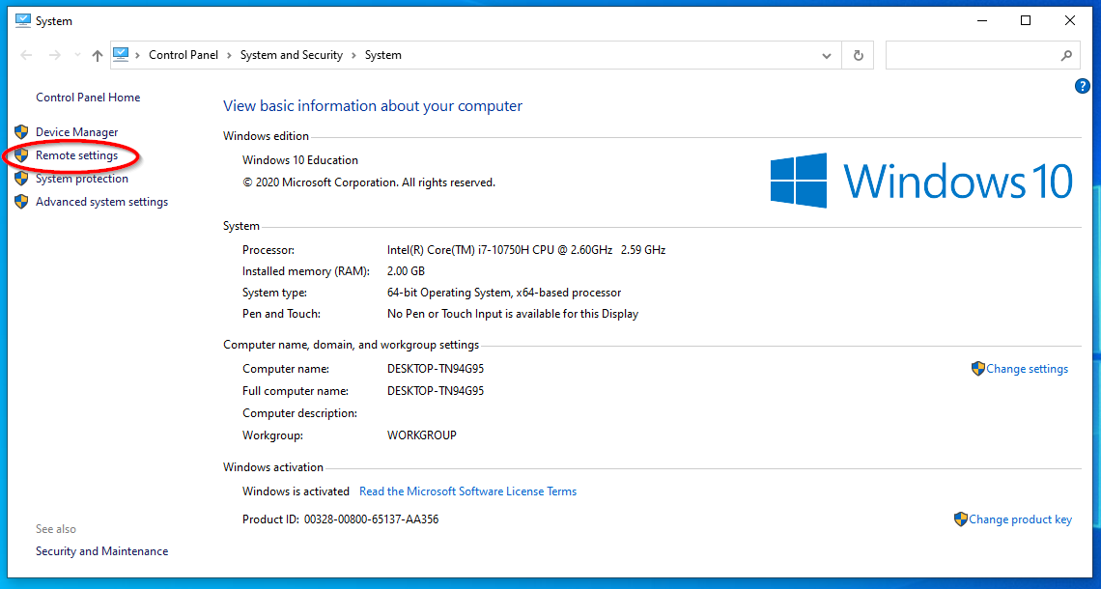

1. In the window that opens, check off the circle to the left of “Allow remote connections to this computer”:

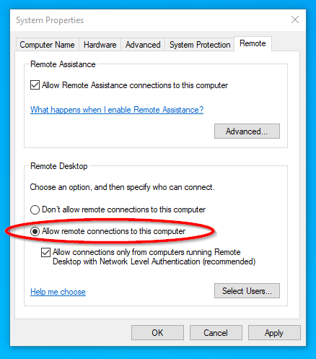

**Step 2: Select Users**

Now Thing2’s user account must be added to their device’s list of remote desktop users:

1. Click **Select Users…**

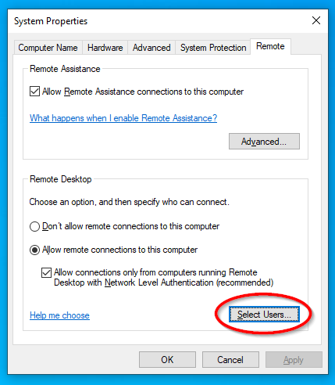

1. In the new window, click **Add…**

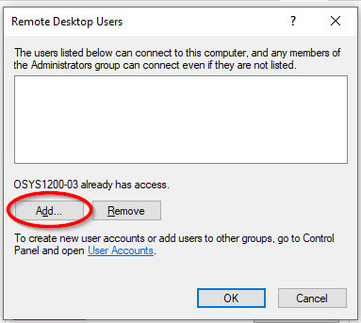

1. In the textbox, type the name(s) of the user(s) to assign remote access to. In this case, the user’s name is “Thing2”. Once the desired users have been entered, click **Check Names:**

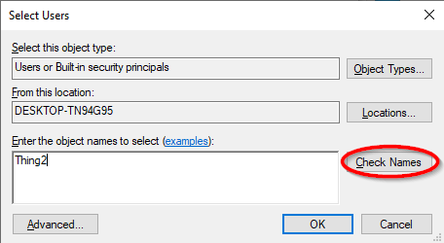

1. After clicking “Check Names”, the entered user(s) will be located by the device and have their username reformatted accordingly:

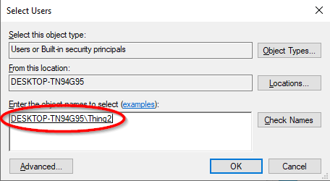

1. Click **OK:**

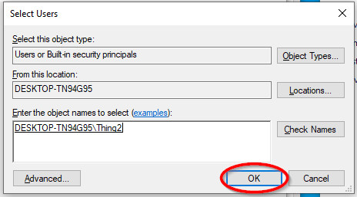

1. Confirm that Thing2 has been added to the list of Remote Desktop Users. Click **OK** to return to the System Properties window:

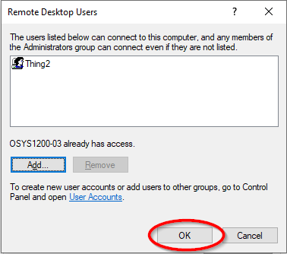

1. Click **OK** to finish:

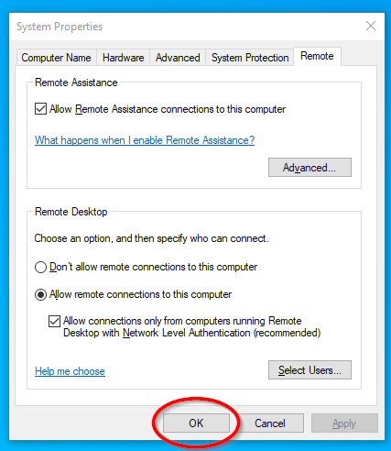

**Step 3 – Access Remote Desktop**

Now that the remote desktop setting has been enabled on Thing2’s device, and Thing2’s user account has been added to the list of remote desktop users on that device, Thing2 can now access their device’s desktop remotely from Thing1’s device:

1. On Thing1’s device, type “remote desktop connection” into the Windows search bar. Click **Open** in the right-hand column:

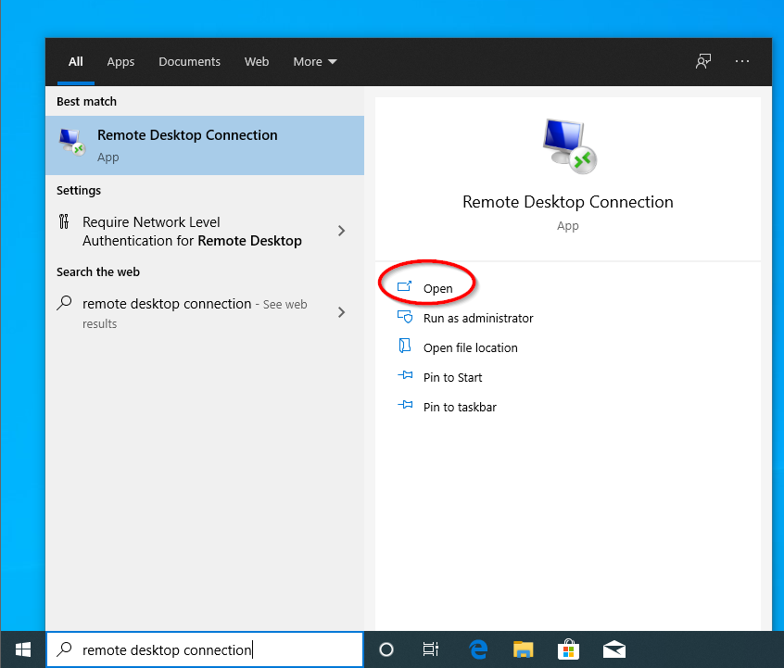

1. Enter the name of the target device to connect to. In this case, the name of the device is THING2DEVICE. Click **Connect**:

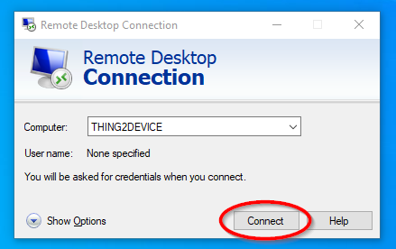

1. A window will appear prompting the user to enter their sign-in credentials. Enter the appropriate username and password then click **OK**:

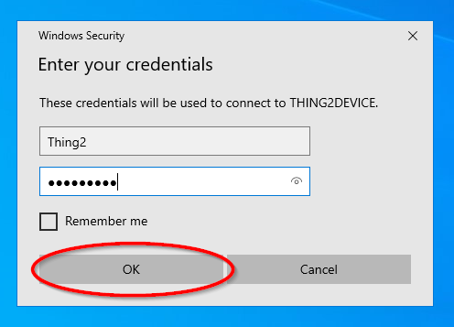

1. A pop-up window will appear to warn the user prior to connecting to the remote device. Click **Yes** onlycertain this is the correct device:

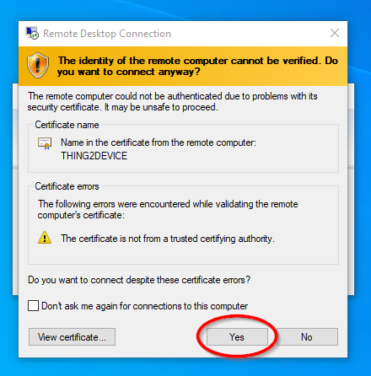

1. A log-in screen corresponding to the entered user’s credentials will appear. Click **Yes** to proceed to the loading screen:

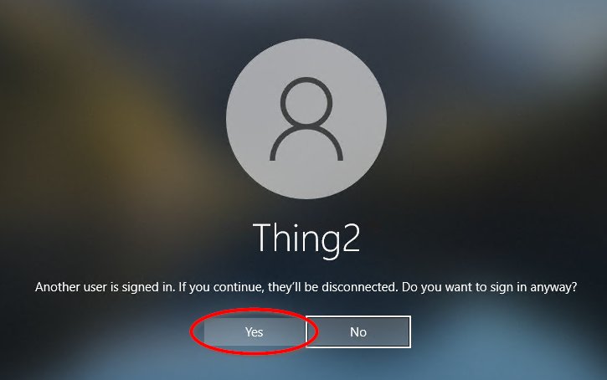

*Note****:*** In this example, only one user can access the desktop at a time. Since Thing2 is already signed in on Thing 2’s device (THING2DEVICE), this window simply notifies us that signing in from Thing 1’s device (THING1DEVICE) will automatically log Thing 2 out on the other device.

1. Thing2 has now successfully accessed the remote desktop of their device (THING2DEVICE) from Thing1’s device (THING1DEVICE):

